第三屆臺灣國際茶碗節
3rd Taiwan International Chawan Festival
參展徵件簡章
Participation Guidelines for Exhibition

「第三屆臺灣國際茶碗節」，預定2025年10月底於「苗栗工藝園區」盛大舉行。臺灣陶文化協會繼2019年第一屆、2023年第二屆臺灣國際茶碗節的豐盛成果，我們將開始徵選國內外優秀陶藝家共同展出，藉由大型的國際性藝文活動，推廣臺灣茶碗茶席文化、陶藝之美與國際文化交流。
The 3rd Taiwan International Chawan Festival is scheduled to take place in October 2025 at the National Taiwan Craft Research and Development Institute-Miaoli Branch. Building on the remarkable success of the 1st Festival in 2019 and the 2nd Festival in 2023, the Taiwan Ceramic Culture Association is now inviting outstanding ceramic artists worldwide to participate in this grand event. Through this international art and cultural festival, we aim to promote Taiwan’s chawan tea ceremony culture, showcase the beauty of ceramic art, and foster international cultural interaction through this grand event.

第三屆臺灣國際茶碗節 主題： 碗然宇宙
每件作品都是一個宇宙，所謂一沙一世界。每個茶碗作品就像一幅畫、一首曲子、一齣戲，展現了作者的宇宙觀，同時在創作的當下，是人和土、水、風和各種萬物元素合作、合而為一的過程，最後加入觀眾的欣賞與使用，更加完整了茶碗裡的宇宙。

參展資訊 Participation Guidelines for Exhibition
- 每位參展者可展出5件茶碗作品或是一組茶碗茶席作品。請參考舉例附圖。
Each artist can exhibit 5 pieces of chawan work or one set of chawan tea ceremony setting. Please refer to the attached photos for examples.
- 作品須可販售。作者自行定價。如有售出，主辦單位將收取定價之50%作為本次活動費用，作者拿回50%。
The work must be available for purchase. The artist may set their own price. In the event of a successful purchase transaction, the organizer is entitled to receive 50% of the listing price as a fee for the event, while the artist is entitled to the other 50%.
- 展覽地點：苗栗工藝園區（苗栗縣苗栗市水源里水流娘巷11鄰8-2號）
Location: Miaoli Branch (NTCRI) No. 8-2, Shuiliuniang, Miaoli City,
Miaoli County 360019, Taiwan
- 展覽時間：2025. 10.30（四）~11.16（日），展期16天。
Date: Thursday, October 30 to Sunday, November, 2025, 16 days.
- 報名審查：聘請資深陶藝家、專業藝術經理共五位進行審查，通過審查者再行通知繳費。
Registration Review: A panel of five judges, including senior ceramic artists and professional art managers, will conduct the review process. Selected applicants will be notified to proceed with the payment.
- 參展費用：新台幣5,200元（歐元150元）。報名通過審核後，繳費方式另行通知。費用含展覽期間作品保險與展覽專輯一冊，以及展場設計、開閉幕、歡迎晚宴、活動宣傳等費用。（展覽期間參展作家如加購專輯，可享六折優惠）
Registration Fee: 150 Euro (157USD). The applicant will be notified of the method of payment once their application has been reviewed and accepted. The fee will include insurance for the exhibited artwork for the duration of the exhibition and an exhibition catalog, as well as to cover the cost of the exhibition design, opening and closing ceremonies, a welcome dinner, and promotional activities. (Additional copies of the exhibition book can be purchased by the artist at 40% off during the exhibition period.)

- 展覽期間，大會將安排開幕典禮、歡迎晚宴、講座、技藝示範、茶碗茶席、音樂表演、手做體驗課、閉幕式等活動。參展作家可依專長報名擔任「講座」、「技藝示範」講師，或「音樂表演」。如獲安排進入大會活動，主辦單位將提供講師費。
During the exhibition, the organizer will host an opening ceremony, a welcome dinner, seminars, technique demonstrations, chawan tea ceremony, musical performances, hands-on workshops, and a closing ceremony. The exhibiting artist may apply to be a speaker for a seminar, a technique demonstrator, or a musical performer according to their expertise. Should the organizer have the honor of receiving the service of the artist as an instructor, a corresponding instructor compensation will be paid to the artist.
- 作品由作者自行送至竹南蛇窯（苗栗縣竹南鎮公館里7鄰大埔頂7號）代收。郵寄或宅配亦可。
Artists are responsible for transporting their artwork to Zhu-Nan Snake Kiln (No.7, Dapuding, Zhunan Township, Miaoli County, Taiwan) either by mail or by courier.
- 未售出作品，展覽後一個月內由作者自行領回，如須郵寄者，可協助郵寄，運費由作者自理。
Unsold artworks must be collected by the artist within one month after the exhibition. If shipping is required, assistance can be provided, but the shipping cost will be borne by the artist.
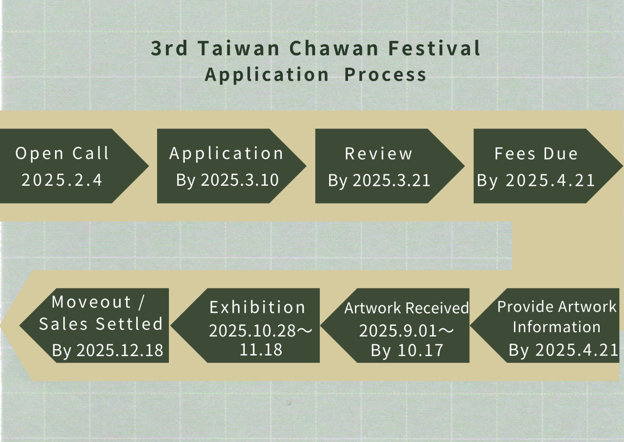
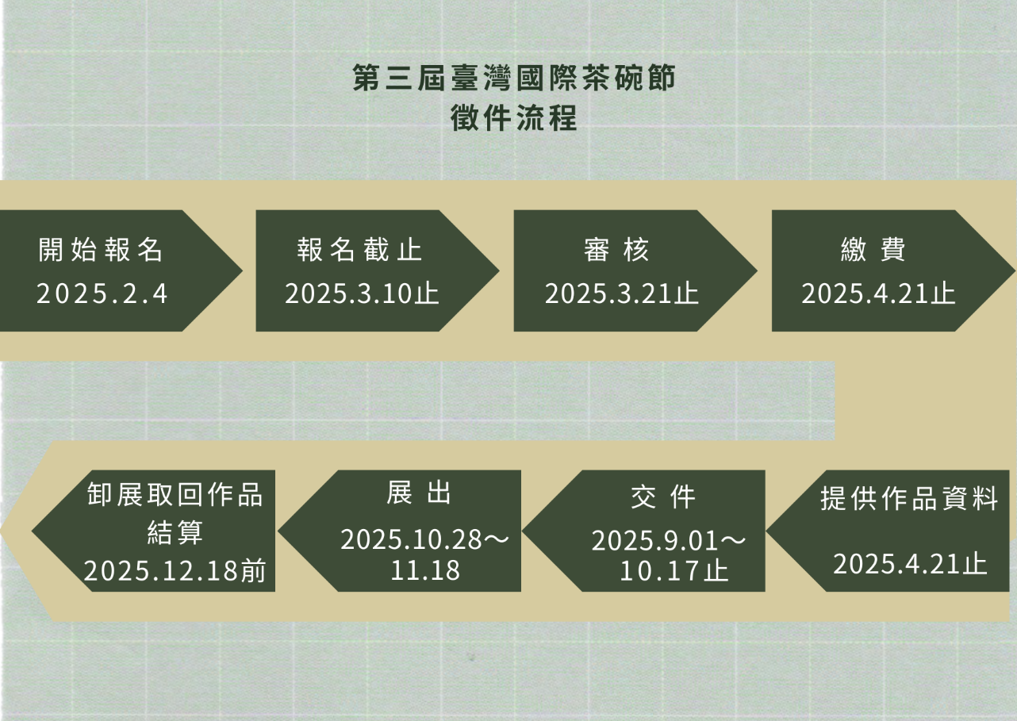
Application by 4. Feb. 2025 > Application Deadline by 10. Mar. 2025 > Review 21. Mar. 2025 > Fees Due 21. Apr. 2025 > Provide Artwork Information 21. Apr. 2025 > Artwork Received 1. Sep to 17. Oct. 2025 Exhibition 28. Oct. to 18. Nov. 2025 > Artwork Retrieval & Sales Settled before 18. Dec. 2025

- 報名資料：
(1)報名表
(2)個人照片一張（生活照或工作照）
(3)參展作品照片五張（檔案名稱請填作者姓名_作品編號，例如：李四_01）
(4)印記或簽名特寫一張
寄至報名信箱：twcca2019@gmail.com
Application Package includes:
- Application Form
- One personal photo (candid or at work)
- Five photos of the artwork (Please use artist's name and artwork number as the file name, e.g. ArtistName_01)
- Close-up photo of a personal seal or signature
Email everything to twcca2019@gmail.com
- 審核通過後將通知繳費，以及後續注意事項。
Once the application has been reviewed and accepted, an email will be sent to notify the method of payment and other information relating to the exhibit.
- 報名截止日期：2025. 3.10
Deadline for application: Ｍarch 10, 2025
- 繳費截止日期：2025. 4. 21
Deadline for Fee Payment: April 21, 2025

主辦單位：臺灣陶文化協會
Organizer: Taiwan Ceramic Culture Association
協辦單位：中華茶藝家研究協會、竹南蛇窯、國際大觀人文茶道書院、金龍窯、興隆窯、樂山窯、河堤上的貓、彩藝得設計印刷、大地原創有限公司
Co-organizers: Chinese Tea Artist Research Association, Zhu-Nan Snake Kiln, Daguan International Humanities Tea Institute, Jinlong Kiln, Shinlong Kiln, Leshan Kiln, Riverbank Cat, CED Printing Co., Initial Art
※洽詢電話：(037)633-661黃經理
For information, email to twcca2019@gmail.com

報名表
姓名 | 中文 |  | 英文
聯絡電話 | 電話 |  | 手機
電子郵件
重要資歷
(至多五項)
創作理念 | 中文（150字內）：
創作理念 | 英文：
作品照片  （請提供每件作品一張照片，檔案格式300dpi） | <作品01>  作品名：  尺寸：  創作年代：  定價：
作品照片  （請提供每件作品一張照片，檔案格式300dpi） | <作品02>  作品名：  尺寸：  創作年代：  定價：
作品照片  （請提供每件作品一張照片，檔案格式300dpi） | <作品03>  作品名：  尺寸：  創作年代：  定價：
作品照片  （請提供每件作品一張照片，檔案格式300dpi） | <作品04>  作品名：  尺寸：  創作年代：  定價：
作品照片  （請提供每件作品一張照片，檔案格式300dpi） | <作品05>  作品名：  尺寸：  創作年代：  定價：
請填妥報名表後，連同
(1)個人照片一張(生活照或工作照)；檔名請標示姓名
(2)作品照片五張（檔案名稱請填作者姓名_作品編號，例如：張三_01）
(3)印記或簽名特寫一張
寄至報名信箱：twcca2019@gmail.com
範例1：茶碗分茶茶席  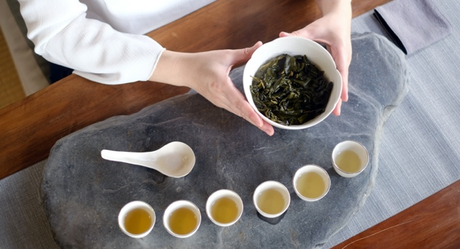 | 範例2：沁涼碗茶  
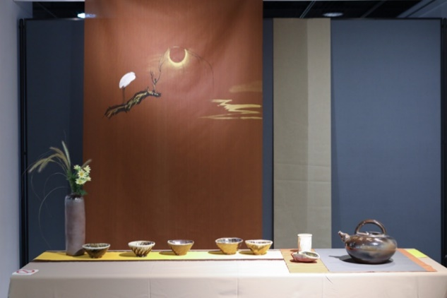  範例3：龍罐茶碗 | 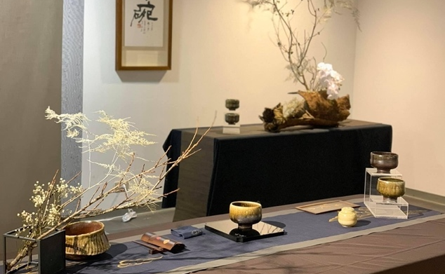  範例4：單碗奉茶

報名表Application Form
Name |  | Nationality
Contact | (e.g. phone number, website)
Email
Address
Career Highlights
(at most 5)
Creative Concept | (no more than 150 words)
Photo of Artwork  (Please provide 1 photo for each piece of artwork at 300dpi) | <Piece 01>  Title:  Size:  Year: 2021  Listed Price:
<Piece 02>
Title:
Size:
Year: 2021
Listed Price:
<Piece 03>
Title:
Size:
Year: 2021
Listed Price:
<Piece 04>
Title:
Size:
Year: 2021
Listed Price:
<Piece 05>
Title:
Size:
Year: 2021
Listed Price:
Please fill out the application form and send it along with:
(1) One personal photo (candid or at work); with your name in the file name
(2) Five photos of the artwork (Please use artist's name and artwork number as the file name, e.g. ArtistName_01)
(3) Close-up photo of a personal seal or signature
E-mail everything to: twcca2019@gmail.com
Ex1: Shared Chawan Tea Ceremony  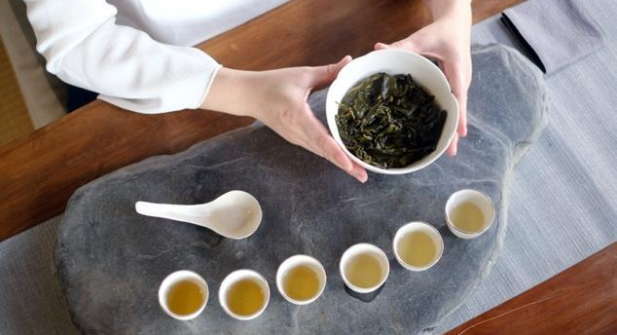 | Ex2: Cold Tea Ceremony  
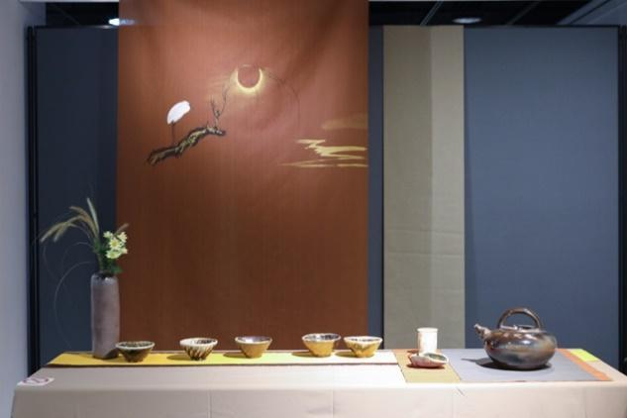  Ex3: Dragon Pot Tea Ceremony | 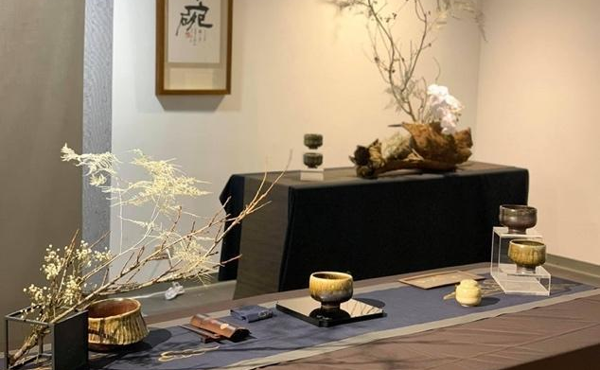  Ex4: Chawan Tea Ceremony

